

Zoe Haggett
zoe.haggett@student.curtin.edu.au

Logbook

RTOS Project Background
An operating system manages the allocation of system resources to the various tasks that need to be performed. Well known examples of an OS include Windows, Mac, Linux, and Android. These are all focused on providing the smoothest experience for the user. In an embedded system environment, we will typically use a real-time OS which is designed to meet strict deadlines to ensure that the system can respond quickly to its environment. We are currently making use of FreeRTOS because it is free to use and has package support built into the STM32CubeIDE.

RTOS Project Deliverables
- Explain what a queue, mutex and semaphore are in the context of an operating system.
  - Describe a suitable use case for each.
- Re-create the LED blink program from 5.3 but use two separate tasks to switch the LED on and off at different rates.
- Create a program that can safely transfer data between two tasks.
  - Some examples of data that could be transferred: Current iteration number, the number of blinks to do, the speed of blinks.
- Provide an Inter-Process Communication (IPC) Diagram or Task Synchronization Flowchart.
  - This should outline how the processes interact, share resources, and avoid race conditions.

Extra Project Deliverables
- Research how an RTOS could be used in a Flight Computer.
Research could include:
- Which tasks the system would be responsible for, e.g. polling subsystems, creating packets, sending packets, responding to commands.
- Which tasks require the highest priority.
- How the system would handle task failures.
WEEK 1: 17 – 23 August 2026
Research Phase
Total Hours Spent: 4
Running Total: 4

19/08/2026 Hours: 2

Introduction to PAST
- Attended first onboarding session and met other software recruits!
- Completed team-building exercises and ice breakers.
- Completed onboarding quiz.

20/08/2026 Hours: 1

Choose Project & Complete Preliminary Research
- Set up logbook.
- Begin basic research questions document – What are RTOSs? Examples? Benefits?
RTOS Project - Research Phase.docx
https://www.ibm.com/think/topics/real-time-operating-system
- Write out which research questions to answer by Week 2.

21/08/2026 Hours: 1

Explore FreeRTOS Beginner Guide and Set-Up
- Read through attached beginners guide - https://freertos.org/Documentation/01-FreeRTOS-quick-start/01-Beginners-guide/01-RTOS-fundamentals
- Download Microsoft Visual Studio, Git Bash, and clone FreeRTOS repository into Visual Studio.
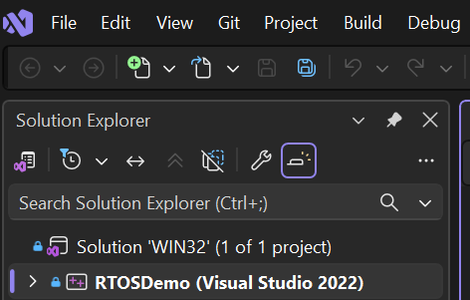
- Watch set-up video attached (given from project repository):
https://www.youtube.com/watch?v=OPrcpbKNSjU

WEEK 2: 24 – 30 August 2026
Total Hours Spent:
Running Total:

26/08/2026 Hours: 2

- Begin first deliverable.
Explain what a queue, mutex and semaphore are in the context of an operating system. Describe a suitable use case for each.
RTOS Project - Research Phase.docx
https://www.tpointtech.com/os-process-queues#google_vignette
https://medium.com/teamshiksha/a-primer-on-queuing-systems-in-computer-science-76743c1196de

WEEK 3: 31 – 6 September 2026
Total Hours Spent:
Running Total:
WEEK 4: 7 – 13 September 2026
Total Hours Spent:
Running Total:
WEEK 5: 14 – 20 September 2026
Total Hours Spent:
Running Total:
WEEK 6: 21 – 27 September 2026
Total Hours Spent:
Running Total:
WEEK 7: 28 – 4 October 2026
Total Hours Spent:
Running Total:
WEEK 8: 5 – 11 October 2026
Total Hours Spent:
Running Total:

